KuaiKuaiInterMart
Cross-Border E-Commerce Platform
User Manual
Version 1.0
June 2026
Prepared by: 阿沙 (Developer & Tester)

Table of Contents
Table of Contents 2
1. Introduction 3
1.1 Accessing the Platform 3
1.2 What You Can Do 3
2. Creating an Account and Logging In 4
2.1 Registering a New Account 4
2.2 Logging In 4
2.3 Logging Out 4
3. Browsing and Searching Products 6
3.1 The Product Catalog 6
3.2 Searching for Products 6
3.3 Viewing Product Details 6
4. Shopping Cart and Checkout 7
4.1 Adding Items to the Cart 7
4.2 Checking Out 7
4.3 Payment 7
5. Managing Your Orders 9
5.1 Viewing Order History 9
5.2 Order Statuses 9
6. Frequently Asked Questions 10
The site takes a long time to load the first time. Is something wrong? 10
I registered but cannot log in. 10
My session ended and I was logged out. 10
Is my payment real? 10
Who do I contact for help? 10

1. Introduction
Welcome to KuaiKuaiInterMart, a cross-border e-commerce platform where you can browse a catalog of products, add items to a shopping cart, place orders, and track your order history. This manual walks through every feature of the platform from a shopper's point of view.

1.1 Accessing the Platform
Open a web browser and go to: https://kuai-kuai-inter-mart.vercel.app
The platform works in all modern browsers, including Chrome, Safari, and Firefox, on both desktop and mobile devices.
Tip: if the very first page load takes up to a minute, this is normal — the server wakes up from an idle state. All following pages load quickly.

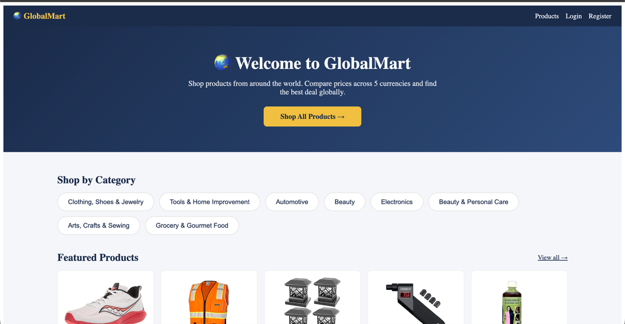
Figure: Homepage of KuaiKuaiInterMart

1.2 What You Can Do
- Create an account and log in securely.
- Browse and search a catalog of 999 products with pagination.
- View detailed information for every product.
- Add products to a shopping cart and adjust quantities.
- Check out and pay through a simulated payment process.
- Review your past orders in the order history.

2. Creating an Account and Logging In

2.1 Registering a New Account
- From the homepage, click the Register link in the navigation bar.
- Fill in the registration form with your username, email address, and a password. Your password must meet the minimum security requirements (it cannot be too short, too common, or entirely numeric).
- Click the Register button to create your account.
- After successful registration, you are taken to the login page to sign in with your new credentials.

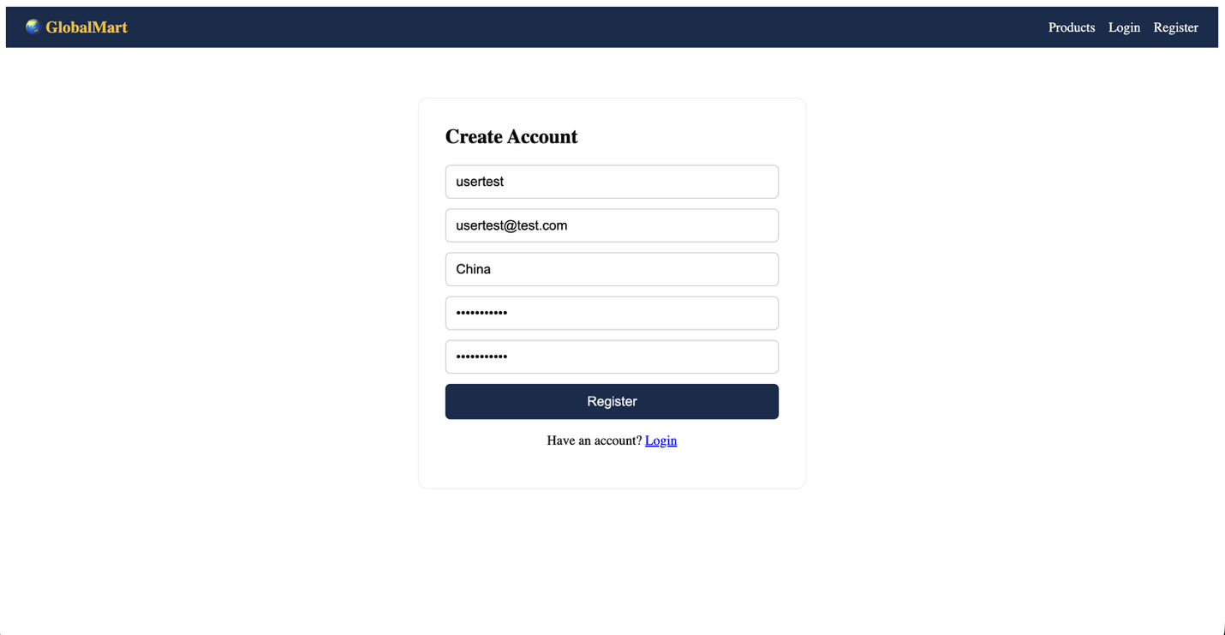
Figure: Registration page with the form filled in
Note: your password is stored using strong encryption (bcrypt hashing) and is never visible to anyone, including administrators.

2.2 Logging In
- Click the Login link in the navigation bar.
- Enter the email address and password you registered with.
- Click Login. On success you are signed in and can access your cart, checkout, and order history.

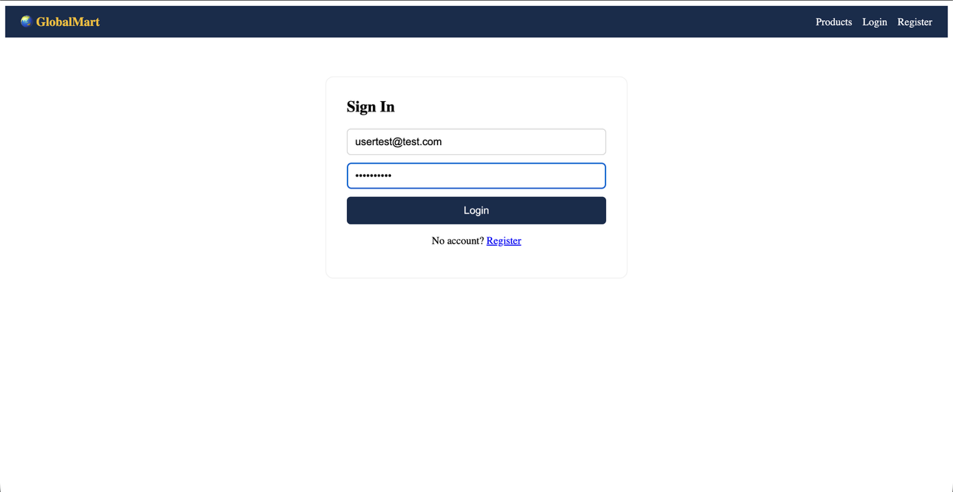
Figure: Login page

2.3 Logging Out
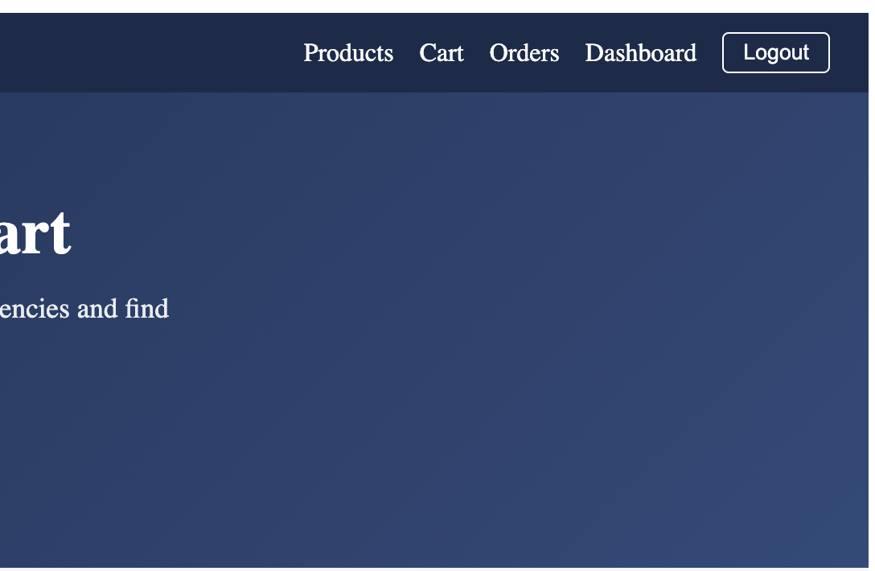
To end your session, click the Logout option in the navigation bar. You will need to log in again to place orders or view your order history.

Figure: Location of the Logout option
3. Browsing and Searching Products

3.1 The Product Catalog
The Products page displays the full catalog. Products are shown in pages of 20; use the pagination controls at the bottom of the list to move between pages.
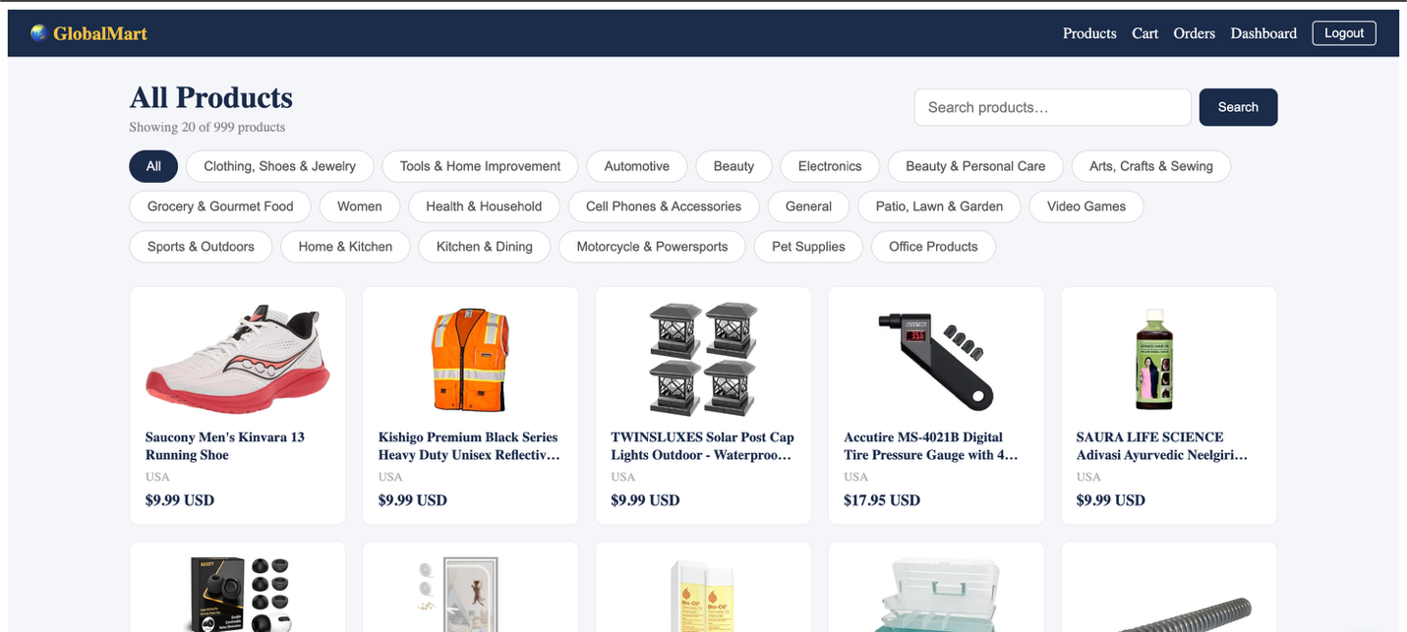
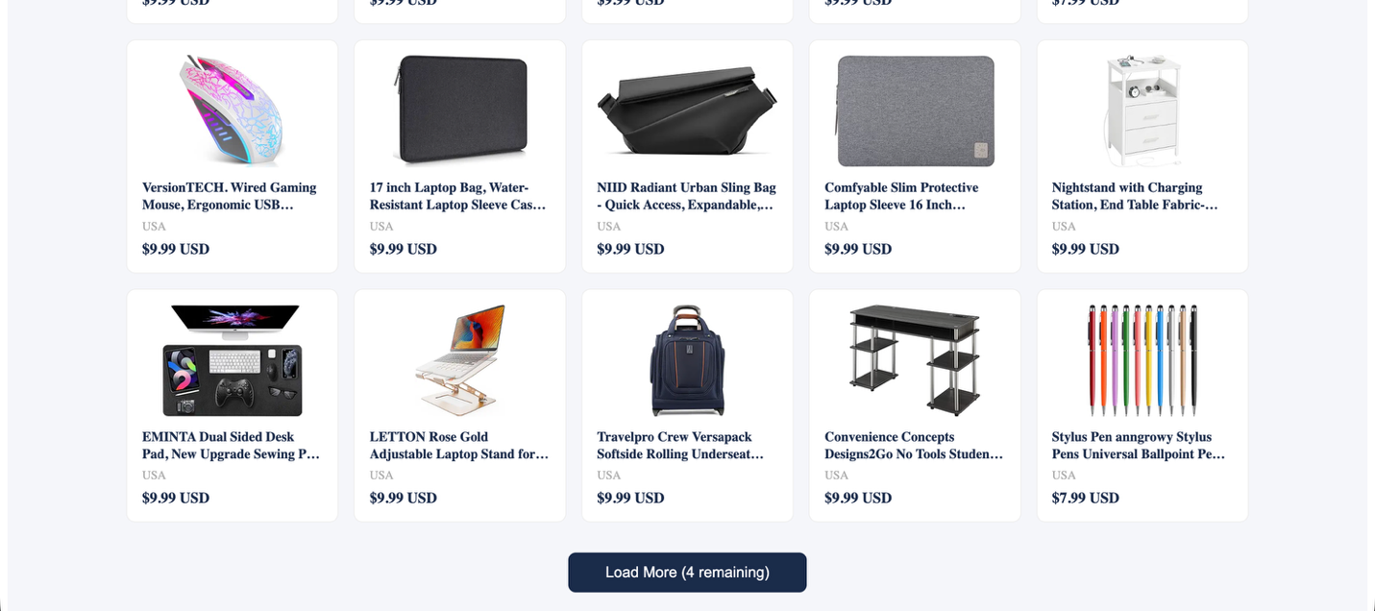

Figure: Product listing page with pagination controls

3.2 Searching for Products
- Locate the search bar on the Products page.
- Type a keyword (for example, a product name or category term).
- The list updates to show only matching products. Clear the search field to return to the full catalog.
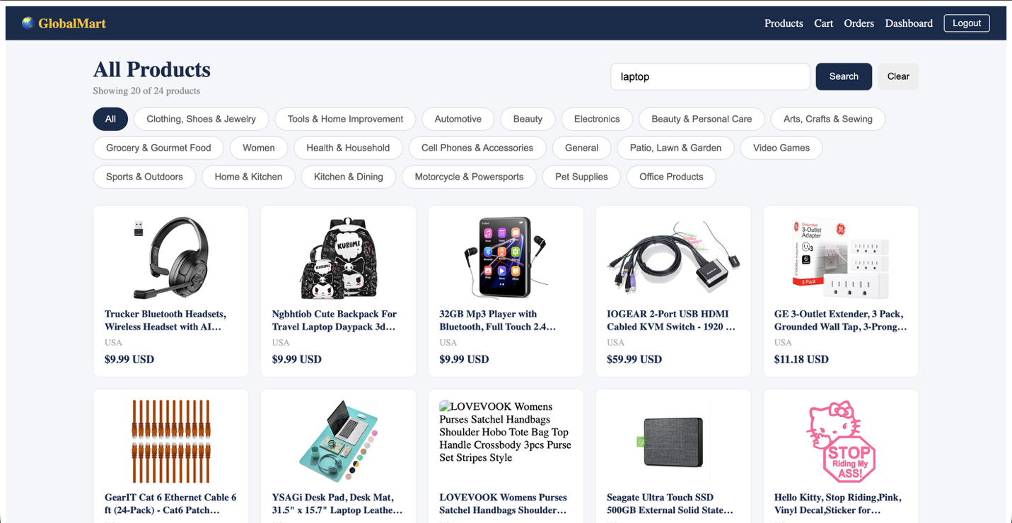

Figure: Search results for a sample keyword

3.3 Viewing Product Details
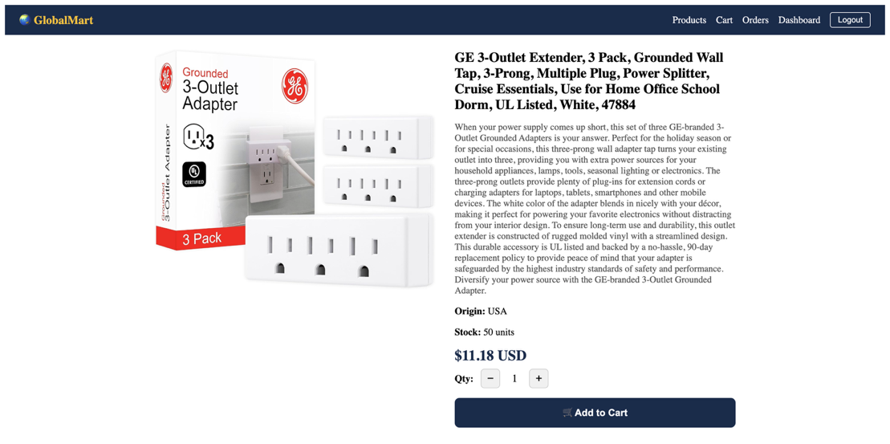
Click any product card to open its detail page, which shows the full product title, price, description, and available stock. From here you can add the product to your shopping cart.
Figure: Product detail page

4. Shopping Cart and Checkout

4.1 Adding Items to the Cart
- On a product's detail page, click Add to Cart.
- Open the Cart page from the navigation bar to review your selected items.
- In the cart you can change quantities or remove items. The total price updates automatically.
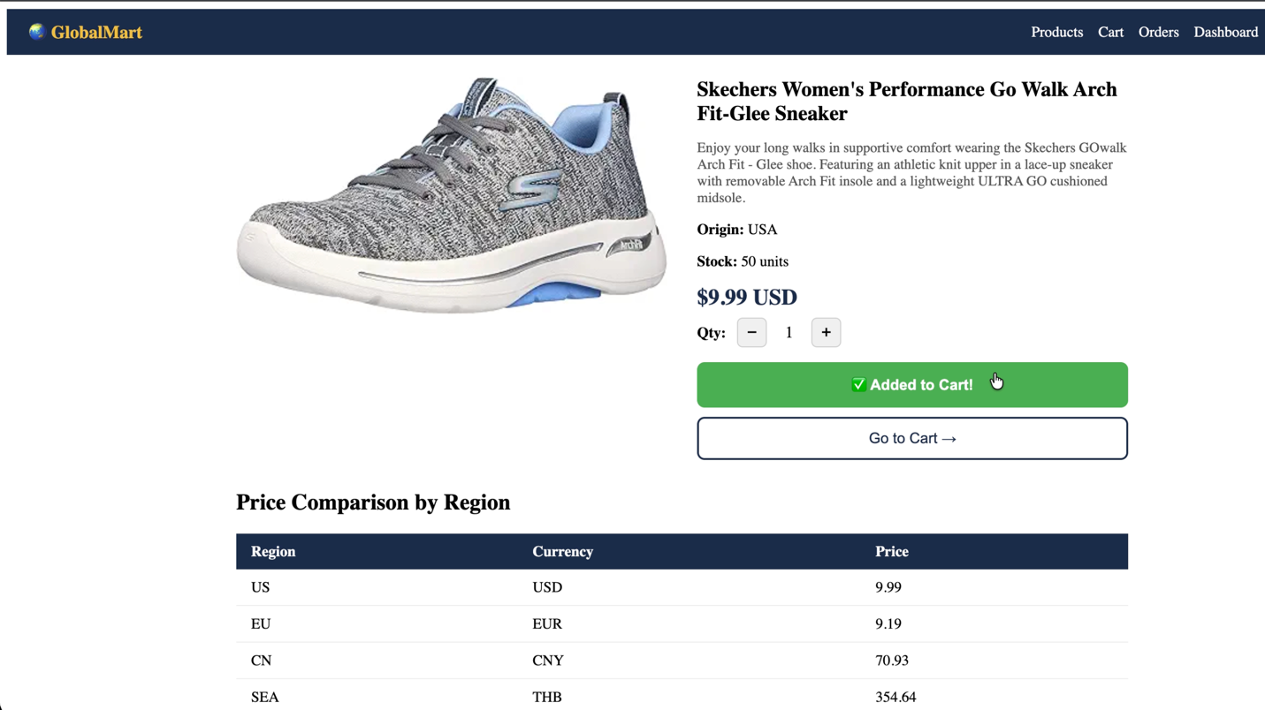

Figure: Shopping cart with items added

4.2 Checking Out
- From the cart, click the Checkout button. You must be logged in to proceed.
- Fill in the required order details, such as your shipping address.
- Review the order summary and confirm to continue to payment.
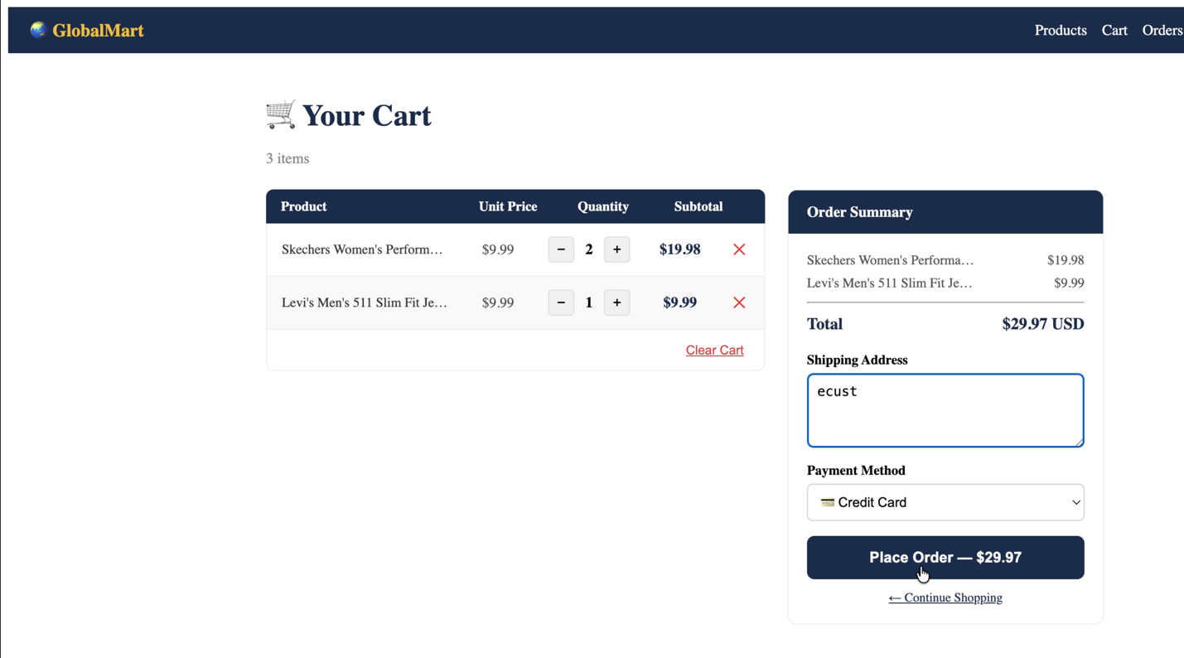
Figure: Checkout page with order details filled in

4.3 Payment
The platform uses a simulated payment process for demonstration purposes — no real money is charged and no real card details should be entered.
- On the payment screen, complete the simulated payment form.
- Click Pay to process the payment.
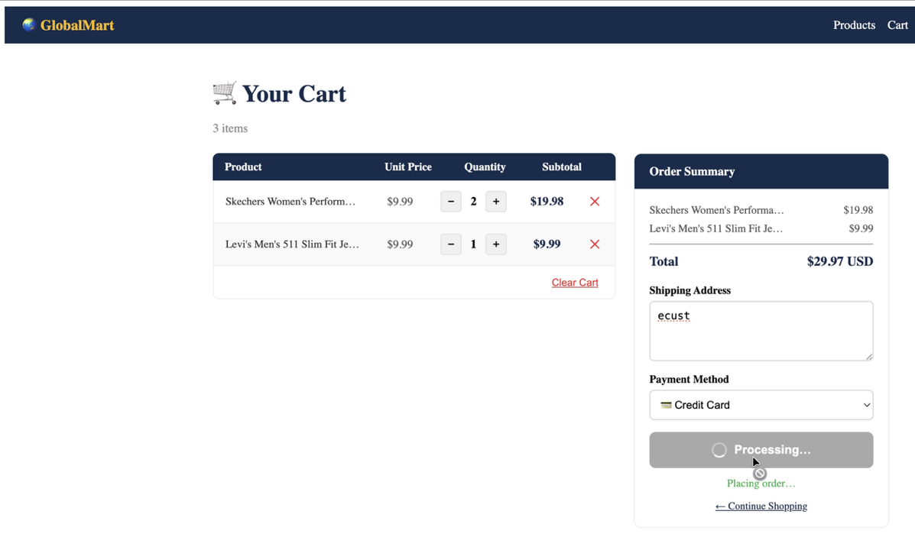
- On success, your order is confirmed and recorded in your order history.

Figure: Simulated payment screen
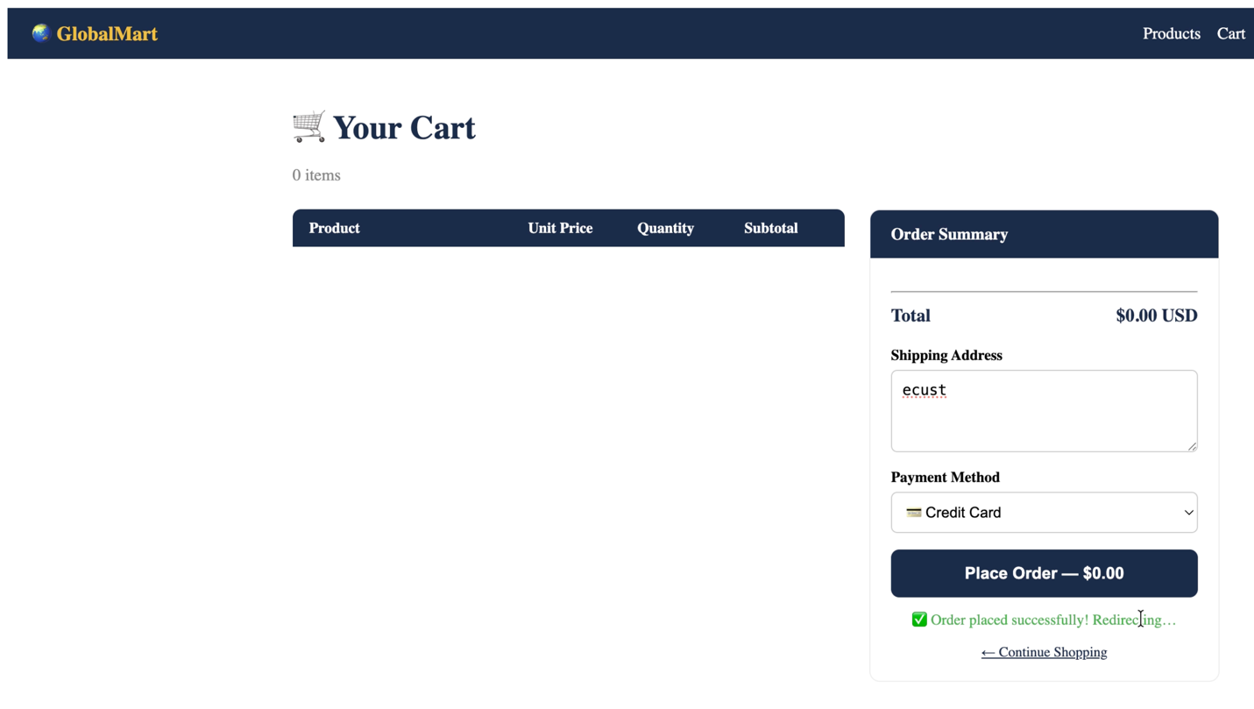
Figure: Order confirmation after successful payment

5. Managing Your Orders

5.1 Viewing Order History
Open the Order History page from the navigation bar to see all orders you have placed, including their items, totals, dates, and current status.

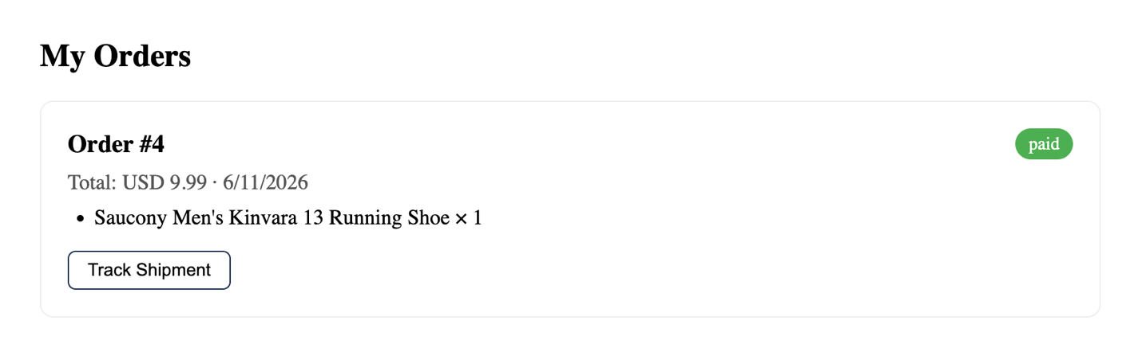
Figure: Order history page showing a completed order

5.2 Order Statuses
Each order displays a status that reflects where it is in the fulfilment process, from payment confirmation through to delivery tracking handled by the logistics system.

6. Frequently Asked Questions

The site takes a long time to load the first time. Is something wrong?
No. The server enters a sleep state after a period of inactivity and takes 30–60 seconds to wake up on the first visit. Once awake, the site responds normally.

I registered but cannot log in.
Make sure you are logging in with the email address you registered with, and check for typos or extra spaces. Passwords are case-sensitive.

My session ended and I was logged out.
For security, login sessions expire after a period of time. Simply log in again — your account and order history are unaffected.

Is my payment real?
No. Payments on this platform are simulated for demonstration purposes only. Never enter real card details.

Who do I contact for help?
For account issues or questions about the platform, contact the system administrator.

